* Create a Console Application to accept a number and print whether the number is even or odd

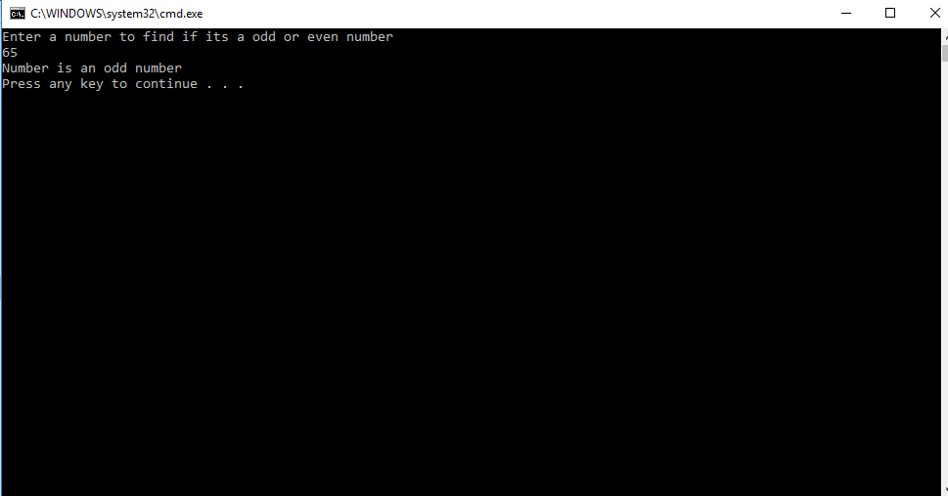

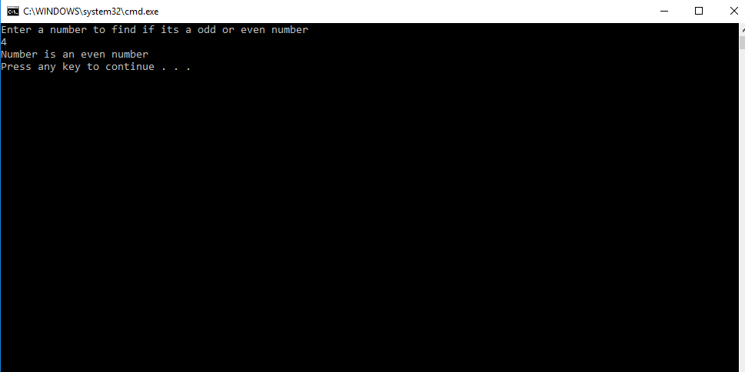

* Generate First 20 Fibonacci Numbers

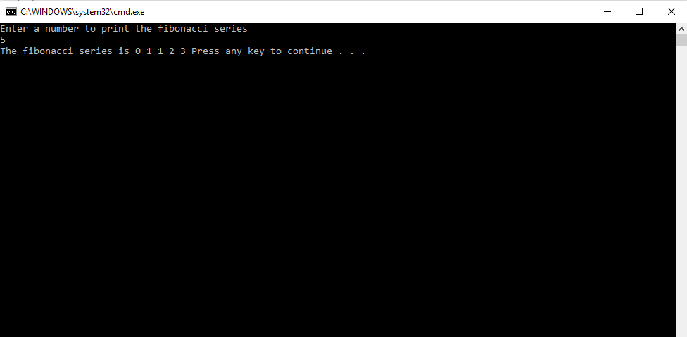

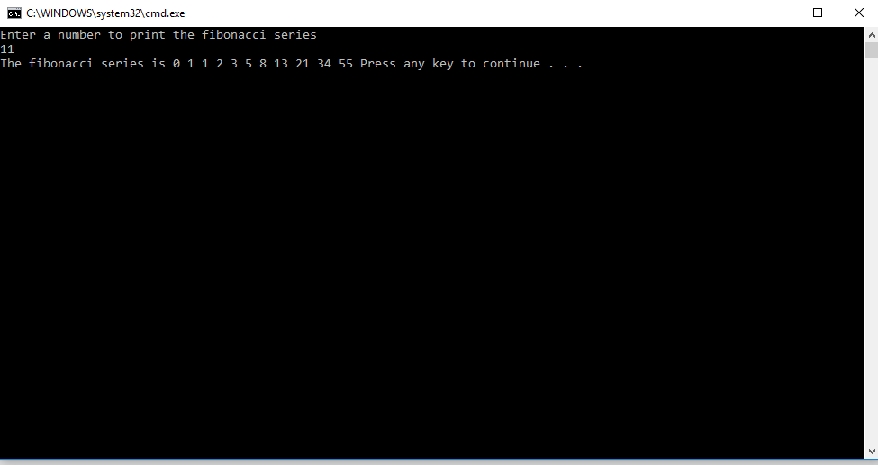

* Create a console application to check whether the entered string is a Palindrome or not

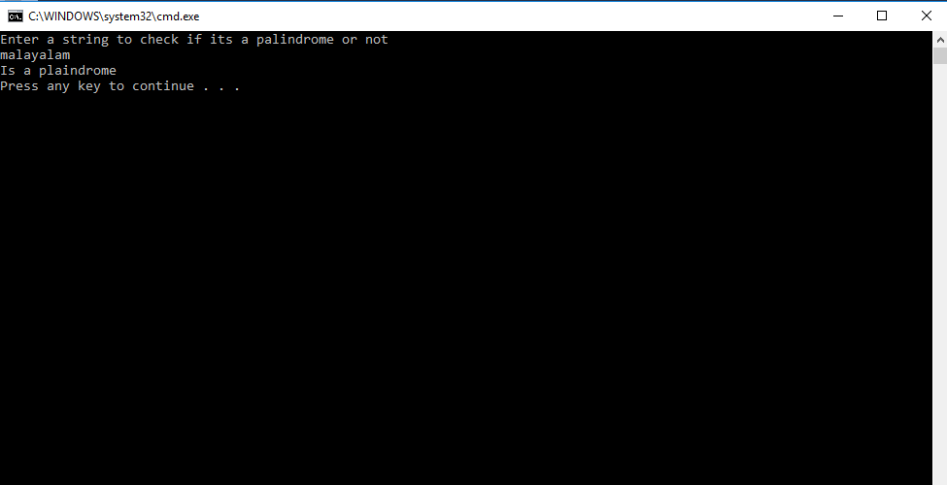

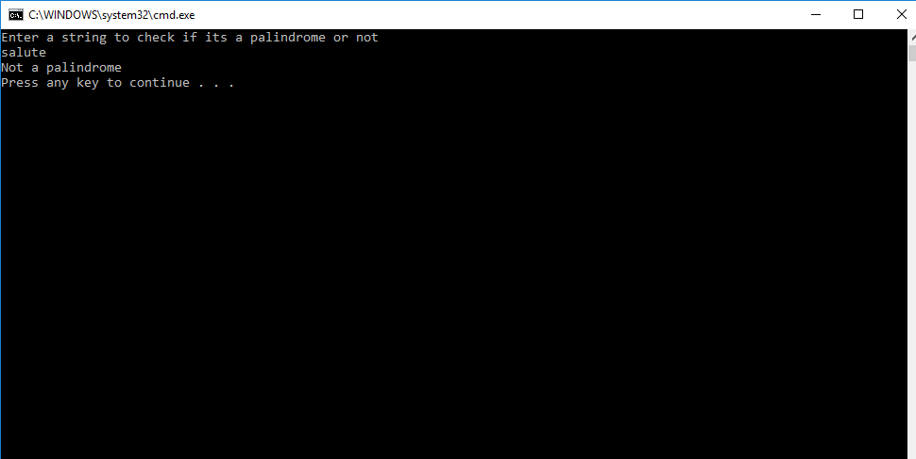

* Create a console application to accept a string and perform below string manipulation on the same
* Print the string in Reverse order

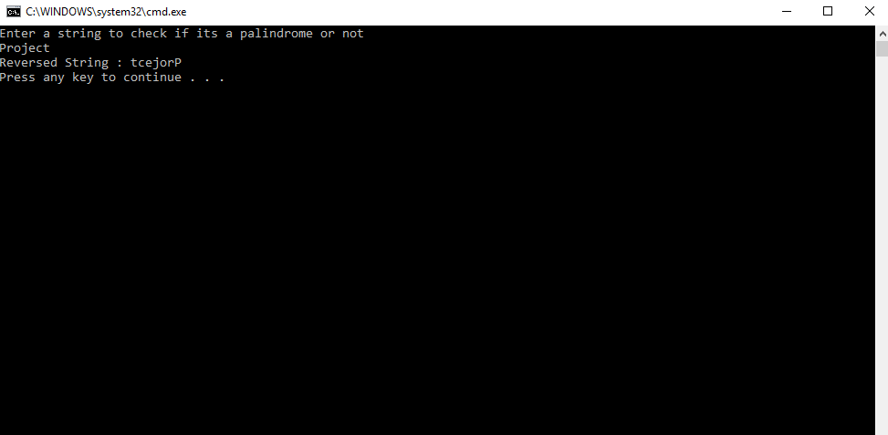

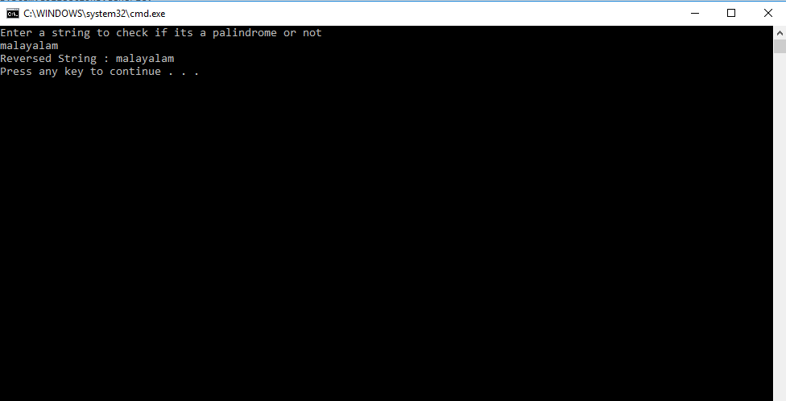

* Extract part of the string from 2nd position till the end of the string

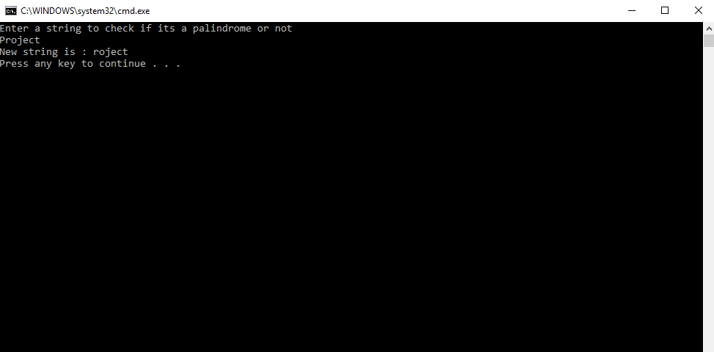

* Replace any character by '$’ and print the same

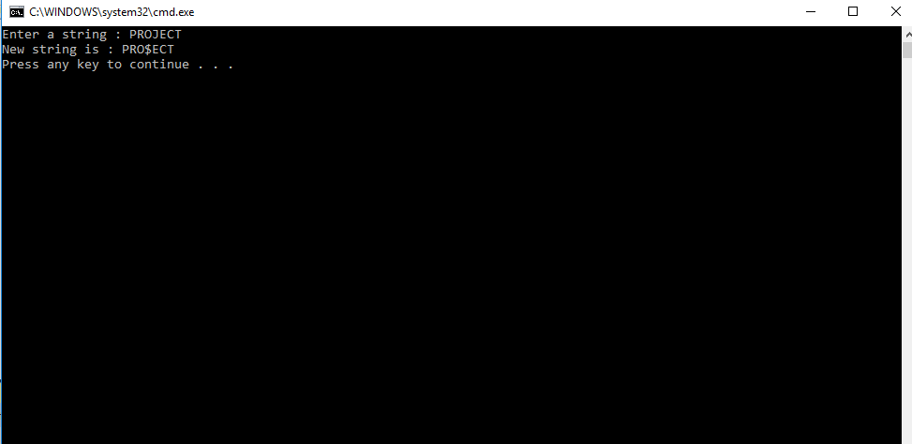

* Copy the string to another string variable and print both the strings

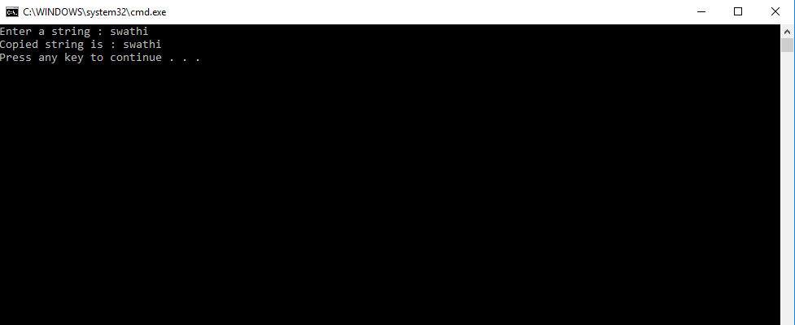

* In this exercise, you will write a program that reads an integer day number (between 1 and 365) from the console and stores it in an integer variable. The program will convert this number into a month and a day of the month and then print the result to the console. For example, entering 40 should result in “February 9” being displayed.

